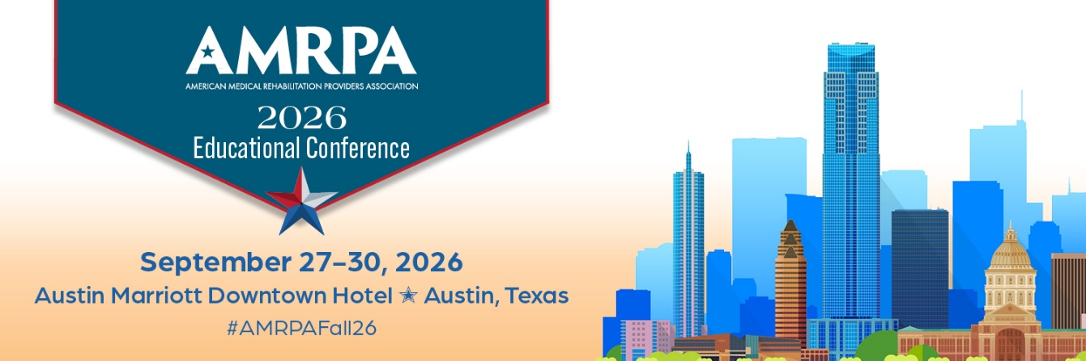

Subject: Request to Attend the AMRPA 2026 Fall Educational Conference & Expo
Dear [Supervisor's Name],
I am writing to request approval to attend the AMRPA 2026 Fall Educational Conference & Expo, taking place from September 27-30, 2026, at the Austin Marriot Downtown Hotel in Austin, Texas.
This premier event, organized by the American Medical Rehabilitation Providers Association (AMRPA), is dedicated to advancing the field of medical rehabilitation through education, advocacy, and the promotion of access to care. The conference offers a comprehensive program focusing on innovative strategies to ensure rehabilitation professionals remain at the forefront of providing high-quality care.
Key Benefits of Attending:
- Educational Advancement: The conference features concurrent breakout educational tracks, such as:
  - Operations and Leadership Development
  - Clinical Care Delivery: A Team Approach
  - Regulatory, Legislative, and Accreditation Matters
  - Business Development and Building Strategic Relationships
  - Technology, Research, and Innovation
  - Building Positive Patient and Staff Experiences
  - Pediatric Rehabilitation
  - Topics Outside the Box

These sessions are designed to provide actionable insights that can be directly applied to our organization's practices.
- Pre-Conference Opportunities: On September 27, attendees can participate in specialized sessions such as the IRF Boot Camp, the eRehabData Expert Analytics and Operations Symposium, or our newest Pediatric Rehabilitation Workshop, offering in-depth knowledge on key issues facing inpatient rehabilitation providers.
- Networking: The event gathers professionals from across the medical rehabilitation field, providing opportunities to connect with peers, share best practices, and explore collaborative solutions to common challenges.
- Continuing Medical Education: Participation may contribute to continuing education requirements, supporting professional development and compliance with industry standards.
Cost Considerations:
- Early Bird Registration (before July 1):
  - AMRPA Member: $845
  - Non-Member: $945
- Regular Registration (after July 1):
  - AMRPA Member: $945
  - Non-Member: $1,045
Additional costs will include travel, hotel accommodations, and meals not provided during the conference. Notably, full conference registration includes access to all sessions, exhibit hall, breakfasts, lunches, networking breaks, and receptions.
I believe that attending this conference will not only enhance my professional skills but also bring valuable insights and strategies to our organization. I am committed to sharing the knowledge gained with our team through a detailed report or presentation upon my return.
Thank you for considering my request. I am happy to discuss this further and provide additional information as needed.
Sincerely,
[Your Name]
[Your Position]
[Your Contact Information]

